**SCENARIO 1**

**The bank needs to process monthly interest for all savings accounts**

**CODE:**

CREATE OR REPLACE PROCEDURE ProcessMonthlyInterest IS

BEGIN

FOR acc IN (

SELECT AccountID, Balance

FROM Accounts

WHERE AccountType = 'Savings'

) LOOP

UPDATE Accounts

SET Balance = Balance + (Balance * 0.01),

LastModified = SYSDATE

WHERE AccountID = acc.AccountID;

DBMS_OUTPUT.PUT_LINE(' Interest applied to AccountID: ' || acc.AccountID ||

' | New Balance: ' || TO_CHAR(acc.Balance * 1.01, '9999.99'));

END LOOP;

END;

/

To run the procedure

BEGIN

ProcessMonthlyInterest;

END;

/

**OUTPUT:**

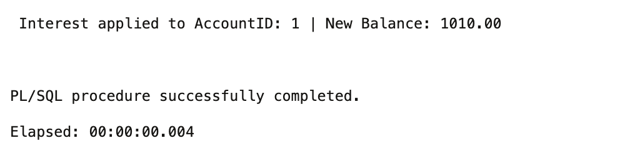

**SCENARIO 2**

**The bank wants to implement a bonus scheme for employees based on their performance.**

**CODE:**

CREATE OR REPLACE PROCEDURE UpdateEmployeeBonus (

p_department IN VARCHAR2,

p_bonus_percent IN NUMBER

) IS

BEGIN

FOR emp IN (

SELECT EmployeeID, Name, Salary

FROM Employees

WHERE Department = p_department

) LOOP

UPDATE Employees

SET Salary = Salary + (Salary * p_bonus_percent / 100)

WHERE EmployeeID = emp.EmployeeID;

DBMS_OUTPUT.PUT_LINE('Bonus applied to ' || emp.Name ||

' (ID: ' || emp.EmployeeID || ') | New Salary: ' ||

TO_CHAR(emp.Salary * (1 + p_bonus_percent / 100), '999999.00'));

END LOOP;

END;

/

To run the procedure:

BEGIN

UpdateEmployeeBonus('HR', 10);

END;

/

**OUTPUT:**

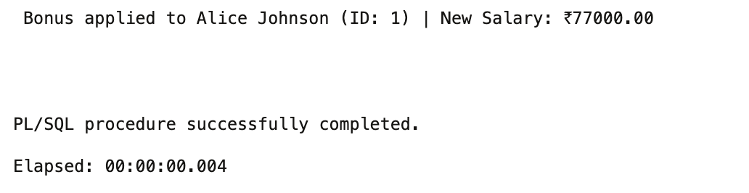

**SCENARIO 3**

**Customers should be able to transfer funds between their accounts.**

**CODE:**

CREATE OR REPLACE PROCEDURE TransferFunds (

p_fromAccountID IN NUMBER,

p_toAccountID IN NUMBER,

p_amount IN NUMBER

) IS

v_from_balance Accounts.Balance%TYPE;

v_to_balance Accounts.Balance%TYPE;

BEGIN

-- Get balances

SELECT Balance INTO v_from_balance FROM Accounts WHERE AccountID = p_fromAccountID;

SELECT Balance INTO v_to_balance FROM Accounts WHERE AccountID = p_toAccountID;

-- Check balance

IF v_from_balance < p_amount THEN

DBMS_OUTPUT.PUT_LINE('Transfer failed: Insufficient balance in AccountID ' || p_fromAccountID);

ELSE

-- Deduct from source

UPDATE Accounts

SET Balance = Balance - p_amount,

LastModified = SYSDATE

WHERE AccountID = p_fromAccountID;

-- Add to destination

UPDATE Accounts

SET Balance = Balance + p_amount,

LastModified = SYSDATE

WHERE AccountID = p_toAccountID;

DBMS_OUTPUT.PUT_LINE('Transfer of ₹' || p_amount || ' successful.');

DBMS_OUTPUT.PUT_LINE('From AccountID: ' || p_fromAccountID || ' | To AccountID: ' || p_toAccountID);

DBMS_OUTPUT.PUT_LINE('Timestamp: ' || TO_CHAR(SYSDATE, 'DD-MON-YYYY HH:MI AM'));

END IF;

END;

/

To run the procedure:

BEGIN

TransferFunds(1, 2, 2000);

END;

/

**OUTPUT:**

